**Homework Tasks**

* You are currently working as an analyst for firms in industry Fama & French 48 : firms with FFI48 industry classifier 21 - 30
* To value companies in your industry, you want to use the Enterprise Value / Sales multiple.
* Theory suggests that the multiple is influenced by profitability, payout, risk and growth. In the following, you want to verify this hypothesis using the following regression equation:

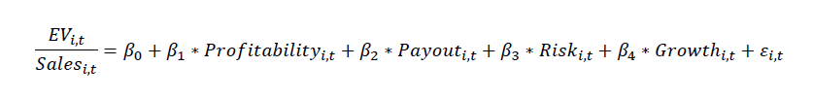For simplicity, these variables are defined as follows:

* **EV / Sales** = (Market Capitalization + Total Liabilities) / Sales
  + Total Liabilities = Short term debt + Long term debt
  + Net Debt = Short term debt + Long term debt – cash and cash equivalents
* **Profitability** = Expected Earnings / Total Assets
* **Payout** = Dividends / Total Assets
* **Growth** = (Expected Earnings – Earnings) / Earnings
* **Risk** = a firm’s CAPM beta (5 years of monthly returns)

1. download the required COMPUSTAT FUNDA data from WRDS
   * **COMPUSTAT FUNDA**: provides a large number of items of annual I/S, B/S, CF/S
   * **Security Monthly (Daily**): provide monthly (daily) stock market data
2. Use the WRDS SAS-Macro to generate an industry classification variable and focus on your respective industry:
   * FFI48: Creates Fama & French 48 Industry Classification Variable (%MACRO FFI48(sic_code))
     1. https://wrds-www.wharton.upenn.edu/pages/support/research-wrds/macros/wrds-macros-ffi48/
   * INDCLASS: Constructs 4 different industry classifications based on SIC, NAICS, GICS and Fama-French industry classifications
   * INDRATIOS: Computes a broad range of financial ratios aggregated at the industry level using Fama-French industry classification

You need the following COMPUSTAT FUNDA items:

* **GVKEY**: Global Company Key in Compustat (Since companies can issue multiple securities a single Compustat GVKEY can be linked to multiple CRSP PERMNOS)
* **IID**: Issue ID ‐ Security in Compustat
* **DATADATE**
  + fiscal year end date in COMPUSTAT’s annual fundamentals file
  + Month end date in COMPUSTAT’s monthly fundamentals file
* **FYEAR:** fiscal year
* **SICH**: Standard Industrial Classification – Historical (A system of four digit codes used in business to classify the industry to which a company belongs)
* **CSHO**: Number Common (ordinary) Shares Outstanding (Siehe CSHOI falls es nicht funktioniert) as of the company's fiscal year-end
* **PRCC_F**: Closing Price annual, fiscal (From Fundamenamentals annualy: funda)
* **IB**: Income Before Extraordinary Items (firm level earnings)
* **SPI**: Special Items (SPI)
* **CEQ**: Common/Ordinary Equity – Total (Book value of equity)
* **ACT**: Current Assets - Total
* **CHE**: Cash and Short-Term Investments
* **LCT**: Current Liabilities - Total
* **DLC**: Debt in Current Liabilities - Total
* **AT**: Assets - Total
* **IVAO**: Investment and Advances Other
* **LT**: Liabilities - Total
* **DLTT**: Long-Term Debt – Total
* **IVST**: Short-Term Investments – Total
* **PSTK**: Preferred/Preference Stock (Capital) – Total (preferred stock, are shares of a company's stock with dividends that are paid out to shareholders before common stock dividends are issued. Preferred stock shareholders also typically do not hold any voting rights, but common shareholders usually do.)
* **SALE**: Sales/Turnover (Net)
* **DVC**: Dividends Common/Ordinary
* For the download, use the following options: indfmt='INDL', datafmt='STD', popsrc='D', consol='C']:
  + indfmt='INDL': Industry Format = Industrial
  + standardized data
  + popsrc='D': for domestic companies
  + consolidated data

1. You need **expected earnings**, in order to calculate the profitability and growth measures in the above regression equation.
   * To obtain expected earnings, compute one-year ahead earnings forecast for the years 2000 to 2018 (HouYear), in line with the approach used in the tutorials.
   * However, instead of using the model by HVZ (2012), use the RI model by Li and Mohanram (2014):

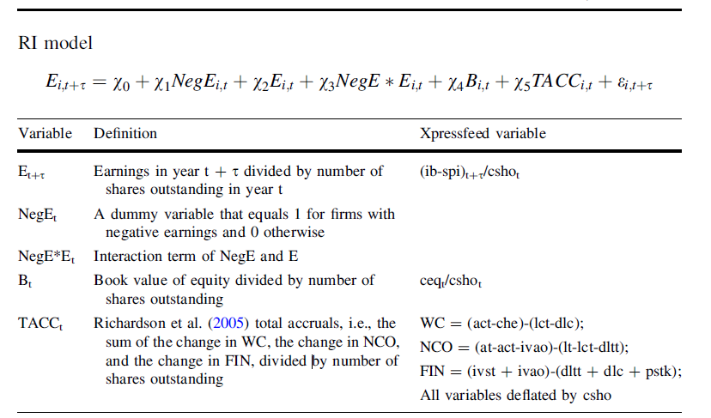

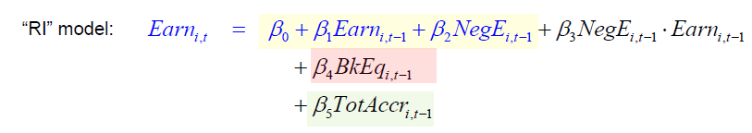



**Firm level earnings**: 

* We set the missing value of AC and TACC to zero.
  + Compute descriptive statistics (N, mean, median, standard deviation) for the forecasts
  + Generate an output table (variable as row and statistics as columns) and export it to an XLSX-file named ‘EmpFin21_GroupNumber_Task1’

1. To compute the risk measure (**Risk** = a firm’s CAPM beta (5 years of monthly returns))
   * you will need the COMPUSTAT SECM data and the Fama & French factors dataset.
   * Please calculate firm-specific CAPM betas each month between January 2000 and December 2018, using a window of 60 months (minimum of 36 months).
   * Compute descriptive statistics (N, mean, median, standard deviation) for the CAPM betas in your industry, generate an output table (variable as row and statistics as columns) and export it to an XLSX-file named ‘EmpFin21_GroupNumber_Task2’.
2. You now have all data needed to calculate the regression variables.
   * Merge the earnings forecasts and the risk measure with the required FUNDA data for your respective industry.
   * Prepare your dataset in line with the approach used in the tutorials and calculate the regression variables for the years 2000 to 2018 (HouYear).
   * Keep only firm-years with complete data for all variables.
   * Further, use statistical criteria, i.e., the interquartile range, to detect and correct (i.e., not delete) mild outliers annually. 🡪
   * Compute descriptive statistics (N, mean, median, standard deviation) for all regression variables, generate an output table (variables as rows and statistics as columns) and export it as an XLSX-file named ‘EmpFin21_GroupNumber_Task3’.
3. Next, you want to verify the hypothesis for the firms in your industry using a rolling regression approach.
   * Run the regressions annually for years 2009 to 2018 (HouYear) with a rolling 10-year window.
   * Save the yearly coefficients and t-statistics in a dataset.
   * To assess the regressions, generate a table with the mean coefficient and t-statistic for each variable (variables as rows and coefficient/t-statistic as columns) and export it as an XLSX-file named ‘EmpFin21_GroupNumber_Task4’.
4. Important: The following task must be done by each group member individually.
   * Briefly describe how you generated the variables (COMPUSTAT item and point in time, e.g. 𝐼𝐵𝑡+1, etc.) in task 1 and provide the regression equation (max. 0.5 page).
   * Also describe the variables used in task 3 (max. 0.5 page).
   * Moreover, interpret the regression results from task 4 and explain if you can verify the hypothesis (max. 0.5 page).
   * In total, do not use more than 1,5 DIN A4 pages with standard text formatting (Times New Roman, font size 12 and line spacing 1.5). Save it as a PDF-file named ‘EmpFin21_GroupNumber_Task5_LastName_FirstName’.

General information:

* To hand in your homework, please send me one ZIP-file per group named ‘EmpFin21_GroupNumber’.
* The ZIP-file must contain the group files (Task 1 – 4), the individual files (Task 5), and your SAS-code.
* The code must be sufficiently commented, such that it is clear what you do in each part of your code.
* Please send the ZIP-file via email to vater@wiso.uni-koeln.de until Monday, June 14th 2021, 23:59.

21 Mach: Machinery

22 ElcEq: Electrical Equipment

23 Autos: Automobiles and Trucks

24 Aero: Aircraft

25 Ships: Shipbuilding, Railroad Equipment

26 Guns: Defense

27 Gold: Precious Metals

28 Mines: Non-Metallic and Industrial Metal Mining

29 Coal: Coal

30 Oil: Petroleum and Natural Gas